Exploring the Financial Market: Investing in Stocks/Shares
According to Wikipedia, "A financial market is a market in which people trade financial securities and derivatives at low transaction costs. Some of the securities include stocks and bonds, raw materials and precious metals, which are known in the financial markets as commodities."
The term "market" is sometimes used for what are more strictly exchanges, organizations that facilitate the trade in financial securities, e.g., a stock exchange or commodity exchange. This may be a physical location (such as the New York Stock Exchange (NYSE), London Stock Exchange (LSE), JSE Limited (JSE), Bombay Stock Exchange (BSE) or an electronic system such as NASDAQ. Much trading of stocks takes place on an exchange; still, corporate actions (merger, spinoff) are outside an exchange, while any two companies or people, for whatever reason, may agree to sell the stock from the one to the other without using an exchange.

Within the financial sector, the term "financial markets" is usually used to refer just to the markets that are used to raise finances. For future finance, they're usually called the capital markets; for short term finance, they're usually called money markets. the cash market deals in short-term loans, generally for a period of a year or less. Capital markets consist of: Stock markets, which give financing through the issuance of shares or common stock, and enable the next trading thereof.

Analysing and studying the Financial Market
To fully exploit the potentials of the financial market, one has got to properly understand how it works as such a lot of effort has gone into the study of financial markets and how prices vary with time. Charles Dow, one among the founders of Dow Jones & Company and The Wall Street Journal, enunciated a group of ideas on the subject which are now called Dow theory. this is often the basis of the so-called technical analysis method of attempting to predict future changes. one among the tenets of "technical analysis" is that market trends give an indication of the future, a minimum of in the short term. The claims of the technical analysts are disputed by many academics, who claim that the evidence points rather to the stochastic process hypothesis, which states that the subsequent change is not correlated to the last change. The role of human psychology in price variations also plays a big factor. Large amounts of volatility often indicate the presence of strong emotional factors playing into the worth . Fear can cause excessive drops in price and greed can create bubbles. In recent years the increase of algorithmic and high-frequency program trading has seen the adoption of momentum, ultra-short term moving average and other similar strategies which are supported technical as opposed to fundamental or theoretical concepts of market behaviour. as an example , consistent with a study published by the European Central Bank, high frequency trading features a substantial correlation with news announcements and other relevant public information that are able to create wide price movements (e.g., interest rates decisions, trade of balances etc.)
The scale of changes in price over some unit of time is called the volatility. it had been discovered by Benoit Mandelbrot that changes in prices do not follow a normal distribution, but are rather modeled better by Lévy stable distributions. the size of change, or volatility, depends on the length of the unit of time to a power a bit more than 1/2. Large changes up or down are more likely than what one would calculate employing a normal distribution with an estimated standard deviation.
To begin investing in the stock market, here are a few steps to take:
- Determine your investing approach.
- Decide how much you will invest in stocks/shares.
- Open an investment account.
- Choose your stocks.
- Continue Investing.

Practical approach to the study and analysis of investing in Stocks/shares (investing.com)
Here we look at a few concepts associated with the stock market. An understanding and careful study of these concepts will enable you make the right decisions:
- Price: A share price is the price of a single share of a number of saleable equity shares of a company. In other words, the stock price is the highest amount someone is willing to pay for the stock, or the lowest amount that it can be bought for.
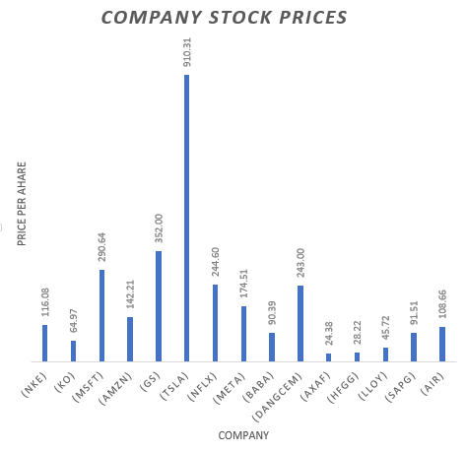
The above chart clearly shows the price per unit shares of a selected number of companies at the time of scraping. Individuals can purchase as much units as available and then receive dividends at agreed intervals which might be quarterly or yearly.

- Change_%: This refers to a price difference between the current price and the last trade of the previous day. Observed as percentages, it gives the percentage loss or gain with respect to previous day’s market close.

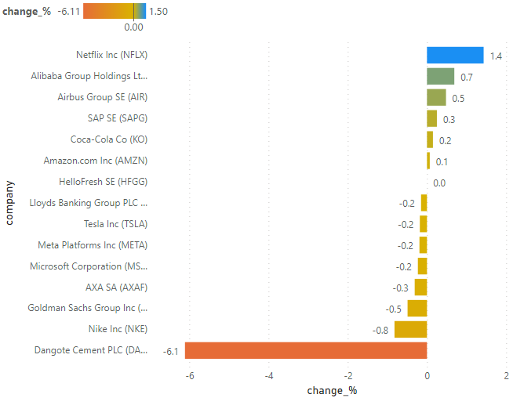
This Change_% chart above depicts the volatility or the performance of a selected number of companies on the stock market. It shows the change in stock prices from the previous day’s market close calculated as percentages.
Conclusion
With the current economic downturn and an increase in the financial enlightenment of so many people who are constantly seeking new ways to help them either save or grow their finances, the financial markets has experienced an enormous amount of attention.
Investing in Shares/Stocks as one of the ways of handling finances is becoming more popular even among the low income earners and an in-depth study into this subject will help in making better decisions as regards gainful allocation of resources.

